Exploration Project

Resources

How to install Luma for the 8x8 led matrix

<https://luma-led-matrix.readthedocs.io/en/latest/install.html>

How to use Luma with the 8x8 led matrix

<https://luma-led-matrix.readthedocs.io/en/latest/python-usage.html#x8-led-matrices>

MAX7219 data sheet

<https://datasheets.maximintegrated.com/en/ds/MAX7219-MAX7221.pdf>

Arduino code for controlling the MAX7219

<https://gist.github.com/nrdobie/8193350>

Github examples and source for Luma led

<https://github.com/rm-hull/luma.led_matrix>

Installation Instructions

Install pip

sudo apt-get install pip

Install Luma

pip install luma.core

pip install luma.led_matrix

Using Luma

from luma.core.interface.serial import spi, noop

from luma.core.render import canvas

from luma.led_matrix.device import max7219

with canvas(device) as draw:

legacy.text(draw, (0,0), "Your string here", *fill*="white",

*font*=proportional(CP437_FONT) )

return None

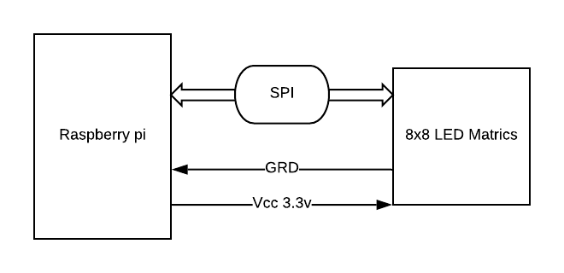

Challenges

Having to learn a wide variety of different packages and libraries to use the 8x8 Led Matrix can be daunting as it abstracts a lot of the spi communication used by the PI. However, anybody familiar with PIL and Pillow will be right at home working with this device.

Issues

Can’t show too much information. Limited to a single digits of text and primitive graphics.